**How to Use this Template**

1. Create a new document, and copy and paste the text from this template into your new document [ Select All → Copy → Paste into new document ]
2. Name your document file: “**Capstone_Stage1**”
3. Replace the text in green

Description

Intended User

Features

User Interface Mocks

Screen 1 (Phone and Tablet)

Screen 2

Screen 3

Screen 4

Screen 5

Key Considerations

How will your app handle data persistence?

Describe any edge or corner cases in the UX.

Describe any libraries you’ll be using and share your reasoning for including them.

Describe how you will implement Google Play Services or other external services.

Next Steps: Required Tasks

Task 1: Project Setup

Task 2: Implement UI for Each Activity and Fragment

Task 3: Build Main Market View

Task 4: Build Watchlist/Portfolio

Task 5: Build Settings/Add Item Activities

Task 6: Build Details Activity

Task 7: Add Polish and Styles

Task 8: Separate Flavors and Publish

**GitHub Username**: shuaybk (<https://github.com/shuaybk>)

Crypfolio

# Description

This is a cryptocurrency price tracking app. It displays the current and historical prices of various cryptocurrencies. Additional features include the ability to set a personal crypto watchlist and to create and track your own personal portfolio of cryptocurrencies.

# Intended User

Anyone that is interested in tracking crypto prices with an Android device.

The target SDK version is 28 and the minimum SDK version is 21.

# Features

The app will be written in the Java programming language using the Android Studio IDE. It uses Gradle v5.4.1.

The API is from Coingecko.com which will provide the cryptocurrency data.

The main page will be an overall market summary of the current top cryptocurrencies. Additional features include:

* A personal watchlist of user selected cryptocurrencies
* A portfolio feature that allows a user to enter their crypto holdings for tracking the portfolio value
* A detail page for any selected cryptocurrency that will display additional details about the currency and provide a chart of the historical price action

# User Interface Mocks

These can be created by hand (take a photo of your drawings and insert them in this flow), or using a program like Google Drawings, [www.ninjamock.com](http://www.ninjamock.com), Paper by 53, Photoshop or Balsamiq.

## Screen 1 (Phone and Tablet)

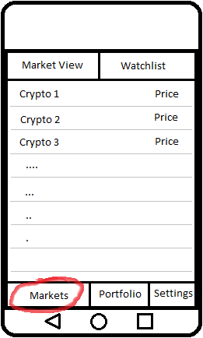 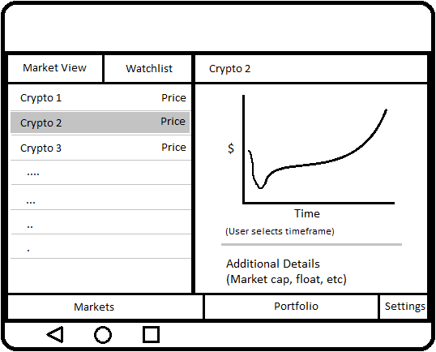

This is the main screen, defaults to Markets tab which allows the user to select the Market View or their Watchlist from the top tabs. The Market View and the Watchlist look similar.

The tablet view will be similar for most of these mocks, only the left side will change to match the phone layout. Therefore, the rest of the mocks will only show the phone UI.

## Screen 2

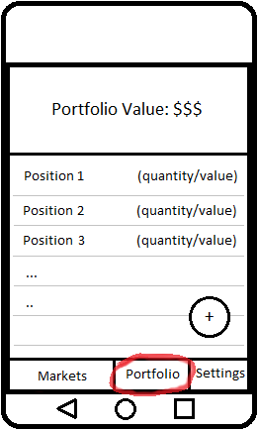

The portfolio page will show the user each of their positions and the current value. There will also be a FAB for adding new entries. Tablet will be similarly laid out (not dual pane)

## Screen 3

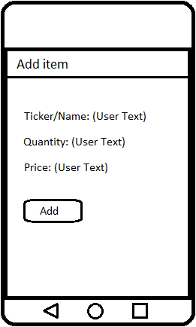

This is the add screen if the user is adding an item to the Watchlist/Portfolio. If it’s the Watchlist, it will only ask for the Ticker/Name. If it’s the Portfolio, it will ask for the Quantity/Price as well. Tablet will be similarly laid out (not dual pane).

## Screen 4

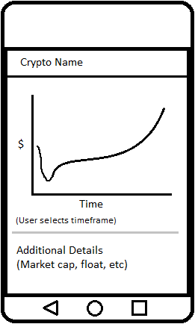

The details screen displays details for any cryptocurrency that is selected. It displays a chart (user can select the timeframe for historical data). It also displays additional details such as market cap, coin supply, etc.

## Screen 5

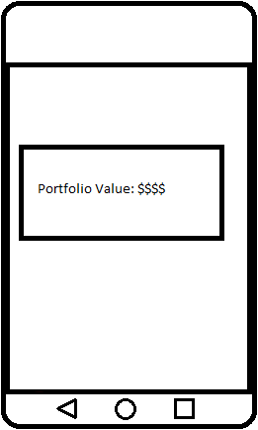

The widget displays the current value of the user’s portfolio. If the user did not create a portfolio yet, it displays a prompt to create a portfolio. Clicking on the widget launches the app into the Portfolio tab.

# Key Considerations

### How will your app handle data persistence?

Data about the user’s watchlist/portfolio will be stored locally on the device in a database using Room. The settings data will be saved locally using Shared Preferences.

### Describe any edge or corner cases in the UX.

If the back button is pressed from any bottom tab or the details/settings screen, the user will be brought back to the Markets tab. If the user is already on the Markets tab, it will take the user to the device home screen.

To delete an item from the Portfolio/Watchlist, the user can do a left swipe or press and hold on the item (which will provide a delete option). A floating action button will be available on the Portfolio/Watchlist to add items as well.

### Describe any libraries you’ll be using and share your reasoning for including them.

* Picasso library v2.71828 will be used for images due to its ease of use and my personal familiarity with it.
* Coingecko is the API for providing the cryptocurrency data (JSON format). It is a free service and provides all the required info.
* Volley library v1.1.0 will be used for making the network requests to the API. This is easy to use and I’m familiar with it.
* Possibly use AnyChart library v1.1.2 to create the graphs, however will need to test this. Alternatively will look up other libraries or use Android’s built-in GraphView to generate the charts.
* Gson library v2.8.6 will be used to parse JSON data. The library is well established/supported, and easy to use.

### Describe how you will implement Google Play Services or other external services.

* Will use Google Play Services for Google Mobile Ads v18.3.0 in a free version. Paid version will remove ad related dependencies.
* Will use Firebase Authentication v19.2.0 to authenticate users (only required if they want to create a Portfolio)
* Will use Cloud Firestore v21.4.0 to save the user’s Portfolio to the cloud.
* The API is from Coingecko.com and provides the cryptocurrency data in JSON format.

# Next Steps: Required Tasks

This is the section where you can take the main features of your app (declared above) and break them down into tangible technical tasks that you can complete one at a time until you have a finished app.

## Task 1: Project Setup

Add the required gradle dependencies for the libraries above:

* implementation 'com.squareup.picasso:picasso:2.71828'
* implementation 'com.android.volley:volley:1.1.0'
* implementation 'com.github.AnyChart:AnyChart-Android:1.1.2'
* implementation 'com.google.code.gson:gson:2.8.6'
* implementation 'com.google.android.gms:play-services-ads:18.3.0'
* implementation 'com.google.firebase:firebase-auth:19.2.0'
* implementation 'com.google.firebase:firebase-firestore:21.4.0'

## Task 2: Implement UI for Each Activity and Fragment

Build the basic UI components:

* Create the tabs and fragments (just the basic views, no real functionality) for each of the required screens. Include FABs and build functionality to switch between views properly. There will be 3 activities:
  + The main view (displays all the fragments)
  + The Settings screen
  + The Add screen
* There will be separate fragments on the main view for each of the below:
  + The main market view
  + The watchlist view
  + The portfolio view
  + The details view

## Task 3: Build Main Market View

Build the functionality required for displaying the main market information

* Create helper classes for making network calls to the API for main crypto market information and storing crypto information
* Make the network calls and retrieve the data in JSON format
* Create a RecyclerView and display the data in a list format

## Task 4: Build Watchlist/Portfolio

* Create a database using Room that will store details about the users watchlist (will store price info as well with LiveData).
* Build Watchlist
  + Pull the watchlist items from its Room database and display saved prices
  + On start, refresh the current prices for the watchlist items (use LiveData to automatically update the prices in the view)
* Build Portfolio
  + Prompt user to authenticate if they are not yet authenticated
  + Pull the user Portfolio items from Cloud Firestore
  + On start, refresh the current prices for the portfolio items (via Volley network call) and recalculate the position values.
  + On delete/edit of a Portfolio item, update the Portfolio in Cloud Firestore

## Task 5: Build Settings/Add Item Activities

Build the Settings activity:

* Save settings info to SharedPreferences
* Make setting option for preferred fiat currency (USD, CAD, etc)
* Add any other required settings

Build the Add Item activity:

* If it’s for the watchlist, just get the ticker/name of the crypto and add it to the watchlist Room database.
* If it’s for the portfolio, get the ticker/name, quantity, and purchase price and update the Cloud Firestore data.

## Task 6: Build Details Fragment

* Determine the crypto that needs details to be displayed (we have it stored in the Main activity already from our initial network calls)
* Create the chart for the historical data (and a selector for the user to pick the timeframe of the chart)
* Display the required additional information about the crypto

## Task 7: Add Polish and Styles

Across the entire app, do the following:

* Localize the app
  + Make sure all strings are defined in strings.xml
  + Add values folder for locale for English (code en_)
* Make sure that the app can be easily adapted for RTL text in the future:
  + Replace any margin/padding items that specify left/right with start/end instead
* Use a consistent theme/colour scheme:
  + Define the primary colors in colors.xml and use these to create styles
* Dual Pane support:
  + For tablets, provide a dual pane layout as per the mocks (dual pane when on the “Markets” tab)
* Resources will be stored in the “res” folder and will have separate files for resources where it makes sense (different locales, screen sizes, flavours, etc).
* Ensure all user entries are validated and do not cause app to crash

## Task 8: Separate Flavors and Publish

Create a paid and free flavor for the app

* Will need separate layouts for each
* Free flavor will have ads, paid flavor will not

Generate a signed APK and publish it to the Google Play Store

Add as many tasks as you need to complete your app.

**Submission Instructions**

* After you’ve completed all the sections, download this document as a PDF [ File → Download as PDF ]
  + Make sure the PDF is named “**Capstone_Stage1.pdf**”
* Submit the PDF as a zip or in a GitHub project repo using the project submission portal

If using GitHub:

* Create a new GitHub repo for the capstone. Name it “**Capstone Project**”
* Add this document to your repo. Make sure it’s named “**Capstone_Stage1.pdf**”